***Documentation***

**Title: dumedite platform (2023)**

**Project description:**

DuMeDite.org was an online platform aimed at facilitating freedom of information (FOI) requests in Kosovo. It sought to enhance transparency of public institutions by enabling citizens to submit FOI requests easily and making responses publicly accessible, in alignment with Kosovo's Law on Access to Public Documents.

**Activities:**Key activities:

* -**Research Phase**: Focused on identifying public needs and knowledge about transparency issues and the Law on Access to Public Documents. This phase involved evidence-based analysis, discussions, and public consultations, followed by a report summarizing the findings.
* **Baseline Analysis**: During the research phase, a comprehensive analysis was conducted on three main thematic areas: legal analysis on transparency and information freedom, skills assessment for journalists and officials, and identifying potential spaces for platform integration with public institutions’ workflows.
* **Focus Groups**: After the soft launch, stakeholder focus groups were organized, representing Kosovo’s central and local government, as well as journalists and activists. The focus groups aimed to address sector-specific needs and improve the platform’s effectiveness.
* **Pre and Post-Tests Evaluation**: These tests measured citizens’ awareness and attitudes toward the platform. Pre-tests were conducted in February, while post-tests were scheduled in November to assess any changes and guide further development.
* **Training of CSO Activists and Journalists**: Training sessions were organized for activists and journalists on how to effectively use the platform, interact with citizens, and help them file FOI requests.
* **Platform Maintenance**: The platform required ongoing maintenance from October 2022 to December 2023, including website hosting and operational support. After project completion, FLOSSK continued to support the platform’s web hosting infrastructure.

**Photos:**

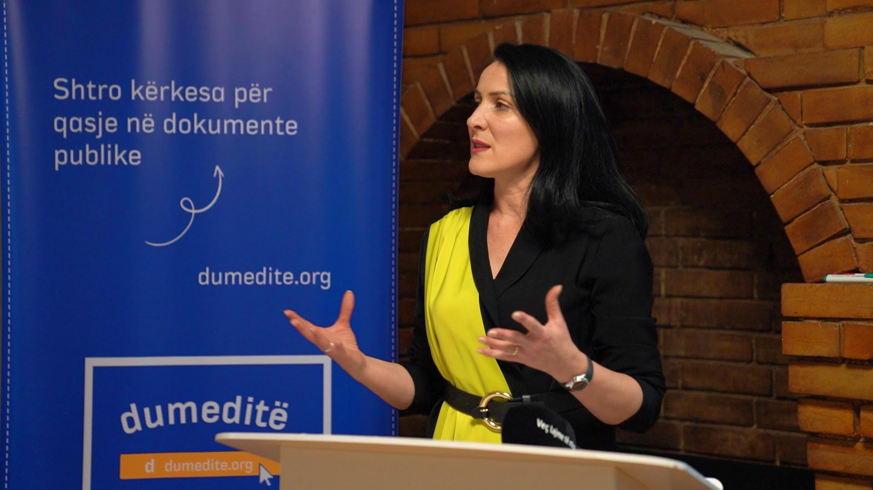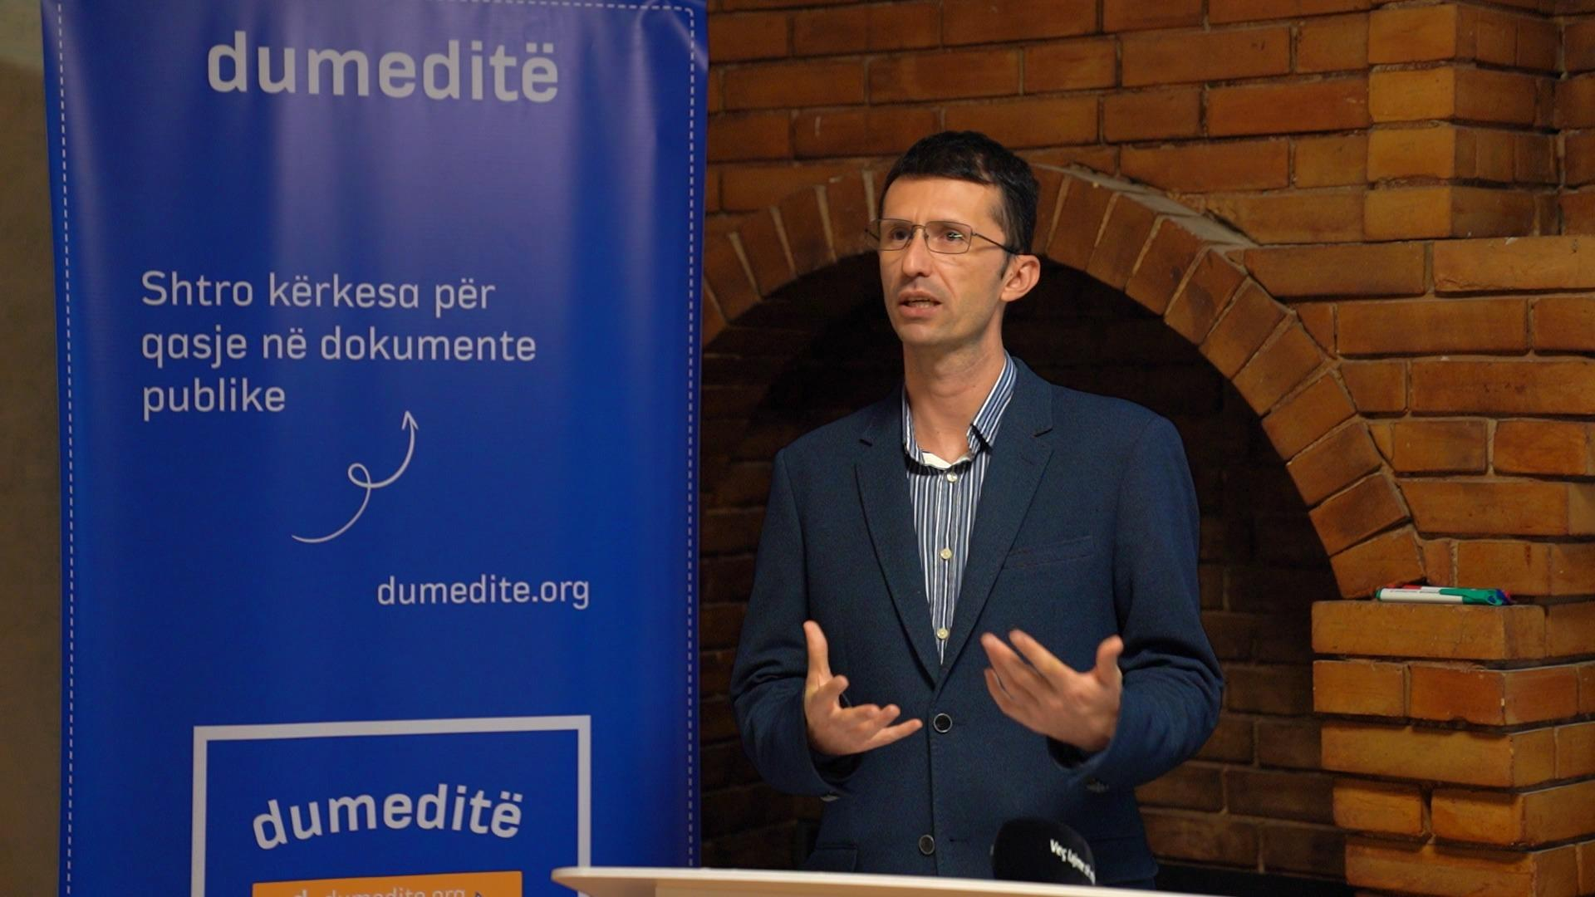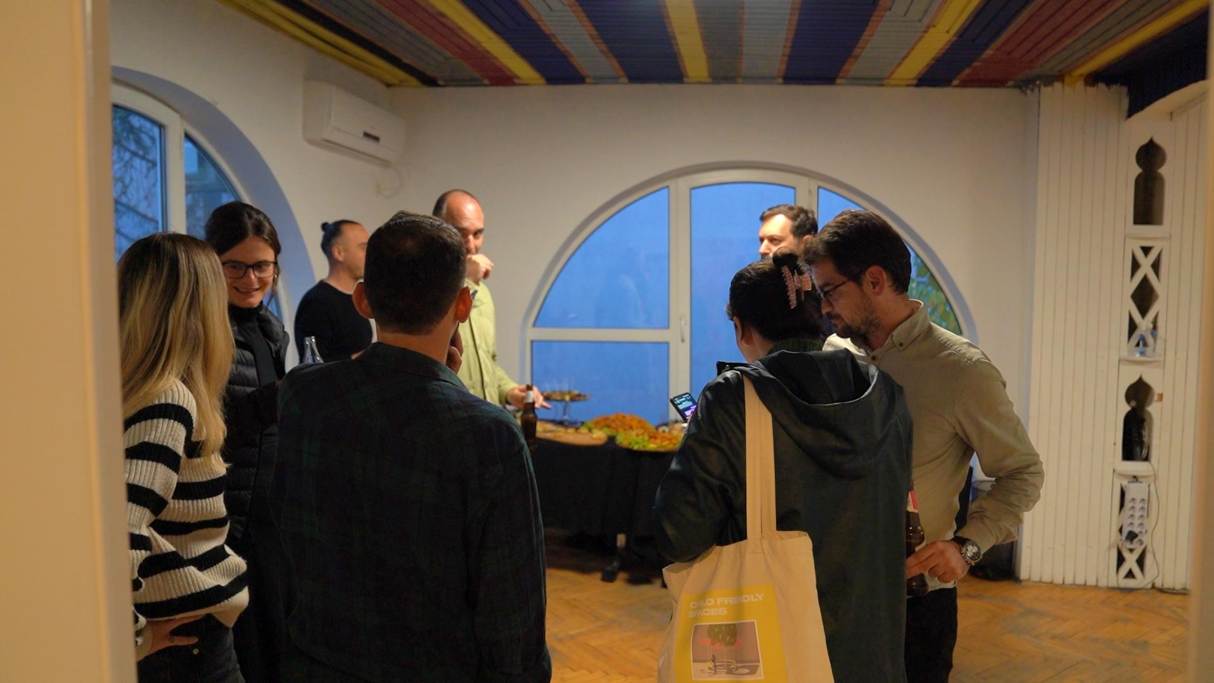

**Beneficiaries:**

Kosovar Citizens who sought greater access to public information. Civil society organizations (CSOs) that advocate for transparency and accountability. Journalists who used the platform to request public documents and promote investigative journalism. Public institutions required to comply with the Law on Access to Public Documents.

**Partners:**

* Funded by National Endowment for Democracy(NED)

**Budget:  
€34,000**

**Project duration**:

October 01, 2022 - December 31, 2023